Plants: Natural Products and Chemical Space

Hassan Haydar 02.12.2025

# Introduction

Natural products are structurally diverse metabolites central to plant function and important in medicine, nutrition, and biotechnology. The metabolite data set from Walker et al. (2023) [1], originally used to explore how metabolic traits relate to plant form and function, captures a wide range of metabolite structural diversity. This analysis investigates whether major natural-product families (NPClassifier subclasses) show distinct chemical properties. I focus on three key descriptors: TPSA (polarity), LogP (lipophilicity), and FractionCSP3 (carbon saturation) calculated with RDKit. By comparing these descriptors and applying PCA, I examine how subclasses differ in polarity and saturation and whether they occupy distinct regions of chemical space.

# Methods

The file *mtbs_tropical_annotations.tsv* from *Walker et al. (2023)* [1] was imported into Python and NPClassifier annotations together with the SMILES structures were retained. All entries lacking a valid SMILES were removed. Molecules sharing the same SMILES were identified and collapsed by grouping on the SMILES string and selecting the most common NPClassifier annotations (“class”, “subclass”, “my_class”). Column names were simplified for convenience, and each unique structure was assigned a structural ID (SID). Only the top 10 most frequent NPClassifier subclasses were included to maintain readability. For every unique SMILES, a set of basic molecular descriptors was calculated using RDKit: molecular weight, LogP, TPSA, hydrogen bond donors and acceptors, ring count, and fraction of sp³ carbons. The resulting descriptor table (df_final) was saved as *mtbs_tropical_descriptors.csv* for subsequent analysis. PCA (scikit-learn) was used to summarize variation across these descriptors, and three descriptor-based visualizations were creared: PCA scatterplot, PCA subclass centroids, a TPSA vs. LogP plot, and a FractionCSP3 violin plot. All analyses were conducted in python (final_project.ipynb)

# Results

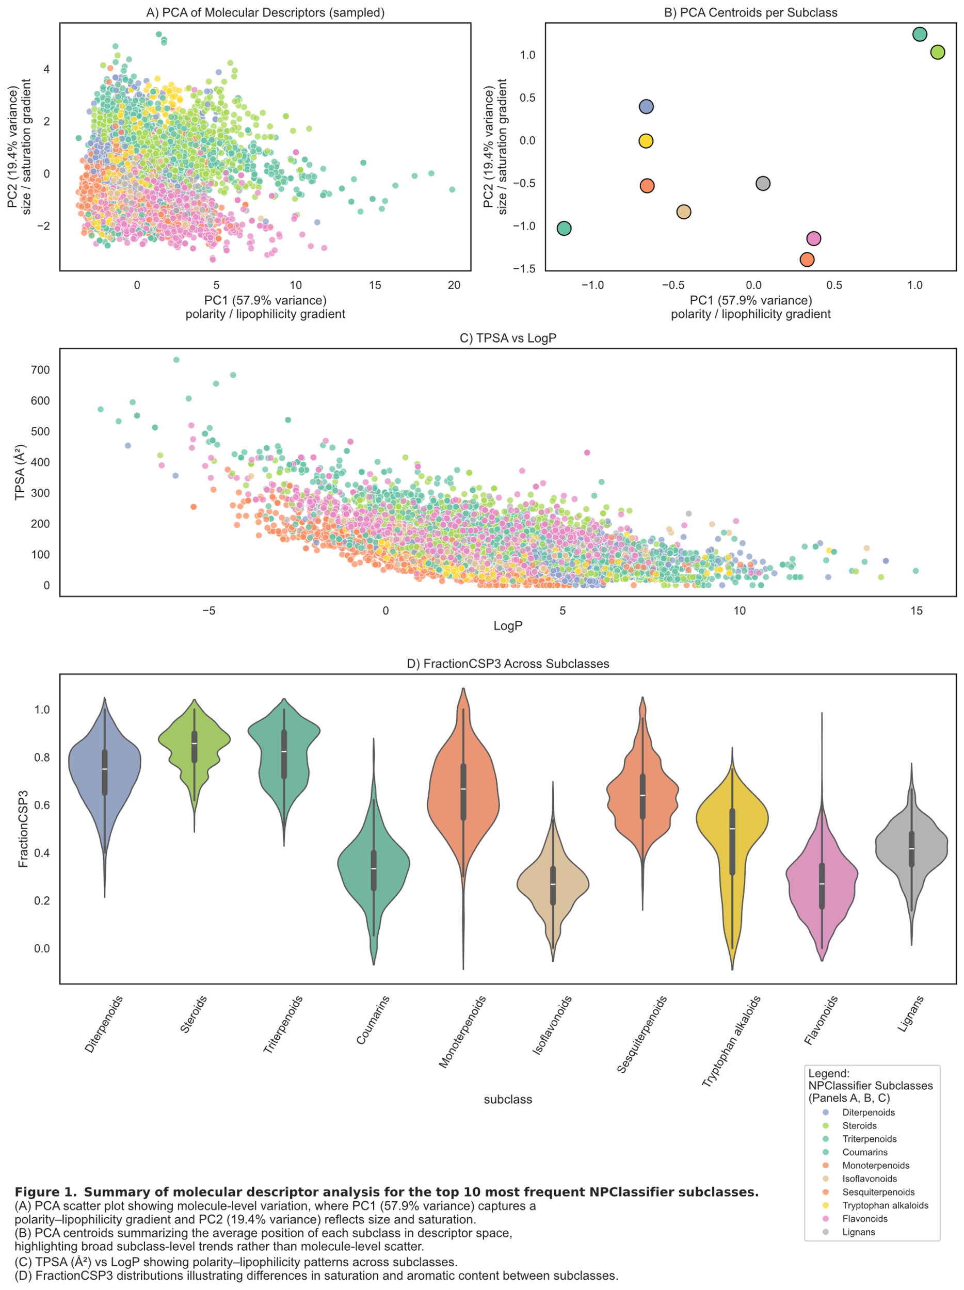

# Discussion

The results show that the top 10 NPClassifier subclasses differ in broad chemical traits. PCA indicates that most variation among metabolites follows two main axes polarity/lipophilicity and molecular size/saturation consistent with the coordinated chemical trait structure described in Fig. 2 of *Walker et. al.* [1]. The TPSA vs. LogP plot shows that subclasses vary in how polar or hydrophobic their metabolites tend to be, aligning with the established role of TPSA as a predictor of transport and absorption in medicinal chemistry [2]. The FractionCSP3 violin plot shows that there is a difference in carbon saturation across subclasses, higher saturation (higher Fsp³) is often associated with improved solubility and better compound progression in drug discovery [3].

References

1. Walker *et al*., *Sci. Adv.* **2023**, 9, eadi4029.
2. *Lovering, Bikker, and Humblet, J. Med. Chem.****2009****, 52, 6752–6756*
3. Ertl, P.; Rohde, B.; Selzer, P. J. Med. Chem. **2000**, 43, 3714–3717.